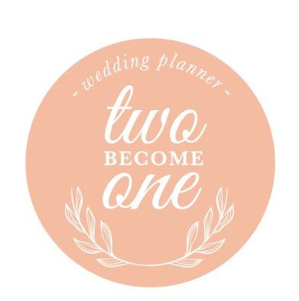Email: info@twobecomeoneweddingplanner.co.uk Tel: 078887 29179

Wedding Planning Checklist

10 months +
After signing your contract with your wedding planner, make any initial payments. Your wedding planner will assist you by contacting all your wedding suppliers that you have already booked, and will have scheduled your first meeting with you to get to know your wedding day dreams and get started on the planning process.
Know your wedding budget based on the type of wedding you would like or based on what you would like to spend. Your wedding planner will manage the wedding day budget.
Finalise your wedding date.
Start to prepare your guest list.
Tour and book the ceremony site and reception venue, if not booked a single site venue. Your wedding planner can assist with negotiating the venue contract.
Choose your save the date cards announcing your wedding date.
Book your photographer. Your wedding planner will recommend 3-5 photographers based on your budget, photography style and your personality.
Your wedding planner can make recommendations for a DJ or live band and book.

8 months +
Your wedding planner will make recommendations for a videographer or cinematographer and book.
Wedding planner can recommend ceremony and cocktail hour music if needed book.
Create your wedding website to share travel information and details with guests if needed.
Wedding planner will make recommendations for Officiant, Priest, Rabbi, Celebrant or Minister and book.
Recommend to your bridesmaids and groomsmen attire to fit the style and colours of your wedding.
Ensure all contracts with wedding suppliers are signed and sent back to them for everything you have booked to this point.
Block off guest rooms or obtain group discounts at hotels for wedding guests.
Wedding planner will make Hair and makeup stylist recommendations and book.
Choose your caterer and have your tastings. The venue may or may not have do all the catering and/or alcohol. Book staff to cater to the food and drink if needed.

6 months +
Look through inspiration/mood boards with your planner and stylist to finalise the overall style and colour palette. Book wedding stylist if looking for lots of styling elements
Wedding planner will make wedding cake designer recommendations and book.
Wedding planner will make florist recommendations and book.
Ensure your transportation is booked. Consider everyone who may need transportation from the ceremony to the reception and at the end of the evening. Include bride and groom, bridal party, parents and guests.
Wedding planner will make Wedding invitation stationery recommendations and book.
Start the rental and linen orders, the catering company may handle this.
Decide on your gift bags or hotel welcome bags.
Remind your bridesmaids and groomsmen to order and purchase their attire.
Order your wedding rings.
Wedding planner will make recommendations for speciality wedding suppliers such as styling props like aisle runners, furniture, wedding arches, balloons, faux floral installations, dried flowers, flower walls, candles, photobooth, light up letters, order of the day signs, postboxes, candy carts and tables, ladders, rose trees, blossom trees, wedding signs etc.
Wedding planner will make wedding stylist recommendations for venue décor/lighting and book.

4 months +
Wedding planner will make recommendations for favours and book.
Update your numbers for the catering and rental orders.
Finalise invitation details. Wedding day invitations are sent 6-10 weeks in advance of the wedding date. Take complete set of invitations to the post office for correct postage.
Order alcohol and beverage items. The caterer or venue may handle this.
Book speciality suppliers.
Wedding table mock up at reception venue.
Schedule bride’s hair and makeup.
Arrange children’s activities, wedding day nannies and magicians if needed.
Wedding day timeline draft to review with bride and groom and update with any changes.
Wedding planner will make recommendations for table stationery such as place cards, table numbers.
1-2 months
Schedule the final walk through at the reception venue.
Ensure final supplier payments are made including wedding planner.
Wedding planner to update all timelines and checklists.

3-4 weeks
Wedding planner to finalise all timings, and details with all suppliers.
Confirm final numbers for all rentals, linens, florals and décor items.
Think about guest seating and table assignments.

1-2 weeks
Confirm final catering count with the caterer and venue
Obtain final seating list, include the number of seats per table to inform the venue and caterer.
Wedding planner to send final timelines to all suppliers and confirm timings and details
Deliver guest gift bags or hotel welcome bags

Day before
Take wedding items to the wedding venue, such as cake serving set, favours, toasting flutes etc.
Some supplier will hand out final payment invoices

Wedding Day
Take wedding attire to venue
Take any items not previously left at venue
Copies of suppliers’ contracts
Wedding planner timelines and checklists
Wedding planner emergency kit
Copy of supplier contact details

